Harry Ferguson
Harry Ferguson was born November 4th 1884. Harry was born in a small Irish town called Growell in County Down about 16 miles from Belfast. Harry Ferguson led a varied and colorful childhood causing mischief where ever he could. He showed mechanical aptitude at a very early stage in life and showed no inclination towards farming much to his fathers disgust. During the first world war Harry Ferguson owned and ran a motor mechanic workshop called Harry Ferguson Ltd, they where also the agents for an American Tractor company called Overtime. This is no doubt where Harry Ferguson and tractors all began.
In 1919 Harry Ferguson was employed by the Irish Board of Agriculture, to improve the efficiency of farm tractor use in Ireland in a bid to improve valuable food production for the country. He concluded that the main problem that existed at that time was the complicated design and construction of the ploughs and the tractors.
Unfortunately at the time the plough was launched in late 1917 Ford Motor car company had begun manufacture of the Fordson 'F', this killed off any market there might be for this plough and tractor conversion. Undetered Ferguson set about designing a plough for the Fordson 'F' after he had sold his stock of original ploughs. Several companies were showing some interest in Ferguson's designs. The most positive talks took place with the Morris Motor Co., who agreed to build a tractor using the Ferguson Hydraulic system, but at the last minute the agreement fell through due to the depression of the late twenties and thirties. As a result was that Ferguson set about building his own tractor, which was assembled at his Belfast workshops in 1933.

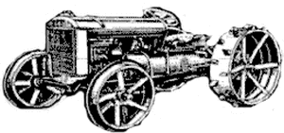
Ferguson Black Prototype Tractor
With the prototype, looking very much like the Fordson, already in existence, Ferguson then set about getting the tractor into production. David Brown of Huddersfield had supplied some components for the Black tractor and following negotiations, agreement was reached whereby David Brown Tractors Ltd., a new company, would build the tractors and Ferguson would take care of the selling. The color of the tractor was changed to battleship grey. Ferguson wanted production models to be black but his staff persuaded him to change. Henry Ford II became chairman of the Ford Empire in 1945. from 1950.
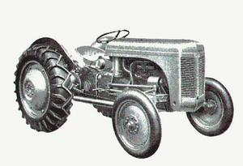
TE Ferguson Tractor
Over half a million Grey Fergies were built from 1946-1956, at the time the largest production run of any tractor in the UK with in excess of half a million tractors built, which has changed farming across the world.

