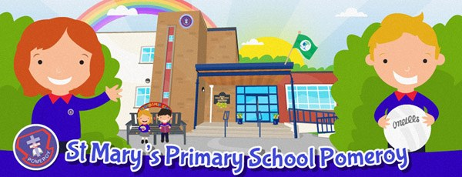
April
Newsletter

Stay updated by checking the School App for any new information.

Closures – Term 3
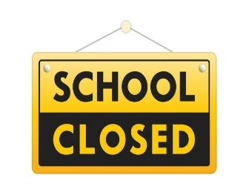
Mon 4th May Bank Holiday
Tues 5th May Staff Development Day
Monday 25th May Bank Holiday
Monday 15th June Staff Development Day
Term ends on Tuesday 30th June 2026 @ 11.00am
REMINDER: School opens every morning for pupils
at 8.50am, when staff are available to supervise.


Tuesday 12th May 2026 Primary 1-4 School Trip – Inflatable World
Saturday 16th May 2026 First Holy Communion
Friday 22nd May 2026 Primary 5-6 School Trip – Emerald Park
Friday 5th June 2026 Butterfly and Rainbow Rooms School Trip – Inflatable World
Friday 12th June 2026 Primary 7 School Trip – SplashWaterpark
All upcoming Football and Running events will be detailed closer to the time.

Physical Activity Timetable
On PE days, pupils can come to school wearing their PE uniform or their normal school uniform only!
***Please note the days the children have afterschool football or running they must come to school in full school uniform and bring PE gear with them.***
All items of clothing must be fully labelled as children tend to leave them behind.

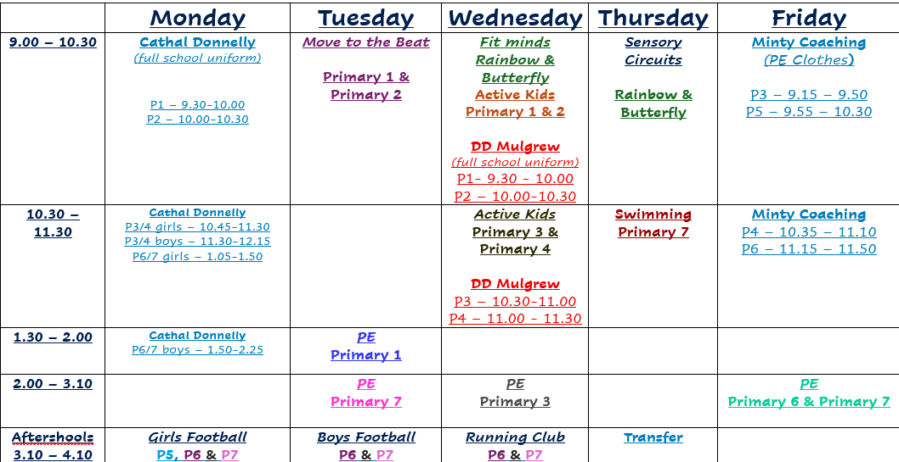


Please note that in the interest of pupil safety as per the safeguarding policy, parents/guardians who are taking pupils out of the school during the school day will be required to sign their child out at the school office.

Hometime Collection
To facilitate safe collection at home-time, can all parents go to the back playground as usual and remain there until the staff bring your children directly to you.

P1: 1.50pm
P2: 2.00pm
P3: 2.50pm
P4/P5: 3.00pm
P6/P7: 3.10pm

Please ensure an adult collects your child and not another child as staff must ensure safe handover.

Social Media
Our class teachers share learning achievements and class celebrations on these platforms to include you in their learning journey at St Mary's.
Website Page: https://www.stmaryspomeroy.com/
Facebook Page: St. Mary's Primary School Pomeroy
Instagram Page: stmaryspspomeroy

