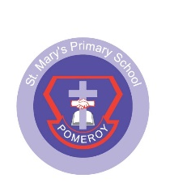
ST MARY’S PRIMARY SCHOOL POMEROY

Dear Parent,

I am writing to update you about our school’s participation in Operation Encompass. Operation Encompass is an early intervention partnership that is currently being rolled out between Police and Schools. It is aimed at supporting children who are victims of domestic violence.

Operation Encompass is already established across all of England and Wales and is now coming to Northern Ireland. It is a very simple idea, but one that will help us to support and protect vulnerable children. When the Police attend an incident of domestic violence where one of our pupils is present, they will inform the school’s Designated Teacher for Child Protection at the start of the next school day. This information is shared in strict confidence and school staff are only told on a need-to-know basis.

Following any notification from the PSNI, our staff will provide immediate support to any child who has been the victim of domestic abuse. We know that when children do witness domestic abuse at home, this is a highly traumatic experience for them. By taking part in Operation Encompass, we can provide tailored and compassionate support to our pupils, in line with our school ethos. This builds on our existing commitment to child safeguarding.

Should you wish to find out more information, please contact the school’s Designated Teacher for Child Protection (Mrs Daly) or alternatively you can read more about Operation Encompass at www.operationencompass.org.

Yours Sincerely,

Mrs Hinfey

