Benadonner knocks at the door of Oonagh and Finns house

Oonagh: Hello, Finn is not here at the minute would you like to come in for dinner and wait for Finn?
Benadonner: Yes, that would be nice where is Finn do you know?
(Benadonner stomps in and hears crying noise coming from the cot)
Oonagh: Here is your dinner this is what Finn eats.
(Benadonner looks at his food but doesn’t eat it and walks over to the cot to investigate)
Oonagh: Why are you not going to eat your stones?
Benadonner: You have a very big baby.
Oonagh: I know Finn is also very very big too.
(Oonagh shows Benadonner all Finn’s spears and the rocks that Finn and his friends throw,
(Benadonner stomped away and ran far away).
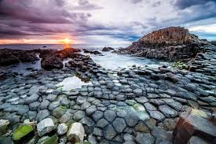
By Laura and Eva

