Harry Ferguson
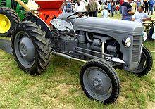
Harry Ferguson was an Irish born engineer and inventor. He was the first person in Ireland to build and fly his own aeroplane. He built a four wheel drive Formula one car. Ferguson was born near Dromore in county Down. With his brother Joe in his bicycle and repair business he developed an interest in aviation. He began to race motorcycles. Harry convinced his brother that they should attempt to build an aircraft. They worked on the design of a plane- the Ferguson monoplane. After making changes and improvements they transported their new aircraft by towing it behind a car through the streets of Belfast up to Hillsborough Park to make their first attempt at flight. At first the propeller didn’t work but they continued to make technical alterations to the plane. After a delay of nearly a week caused by bad weather the monoplane finally took off. Harry didn’t like manual farm labour and was determined to find ways to mechanize farming. In 1928 he invented the three point linkage Ferguson system. The Little Grey Fergie went into production in 1946. He died in 1960.

Aidan Devlin

